# D2L 3rd Party App – SP-04, No Color

# **Date: 08/31/2023**

## Overview

## Project Team

|  |  |  |  |
| --- | --- | --- | --- |
| **Roles** | **Name** | **Major responsibilities** | **Contact (Email and/or Phone)** |
| Project owner | Sharon Perry | NA | (470)-578-6005 |
| Team leader | Sean Work | FLEX (Programming and Documentation) | (404)-645-0818 |
| Team members | Christopher Dymanus | FLEX | (404)-405-3447 |
| Kenneth Molinari | FLEX (Project Website and Programming) | (404)-490-9818 |
| Advisor / Instructor | Sharon Perry | Facilitate project progress; advise on project planning and management. | Sperry46 in D2L !! |

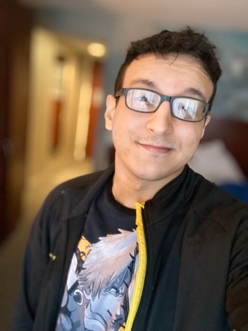 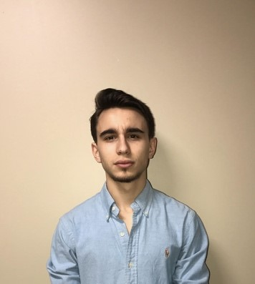 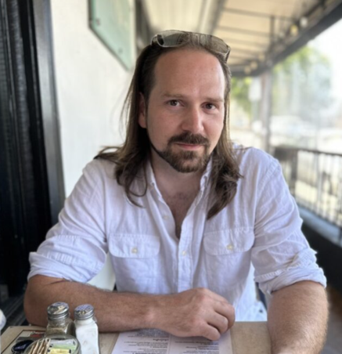

Sean Work Christopher Dymanus Kenneth Molinari

## Project website

<https://d2lprojmanagerapp.azurewebsites.net/>

## Final Deliverables - Specific To Your Project

1. Functioning prototype software of 3rd Party Project Management Application/Extension that will be capable of being posted to the current D2L Marketplace.
2. Report and extensive README Documentation along with all other relevant documentation applicable to our software.

## Milestone Events (Prototypes, Draft Reports, Code Reviews, etc)

#1 - By September 30th 2023

* Majority of documentation is complete.
* Website template basic structure is working with functioning links.
* We have the green light to accomplish the project itself. (tentatively waiting on owner to determine feasibility/ requirements as of 08/31/2023.
* Github version control setup
* Determined language(s) for project.

#2 - By October 30th 2023

* Basic prototype built with minimal functionality. (Project Create, Group Create, Survey Create)
* Ability to see basic deadline stats. (no need for visual cues)
* Website is complete with link to github and relevant documents in PDF format.

#3 - By November 15th 2023

* Bells and Whistles are added on. (Visual Cues, printable presentable reports, etc)
* Potential assimilation with institution for testing.
* Final documentation

## Meeting Schedule Date/Time

Specific time TBD but in the interim we will meet on the 15th of each month via Zoom at 8pm.

## Collaboration and Communication Plan

Our main form of communication will be through MSFT Teams. We will also communicate casually through text and discord throughout the week as needed and will try to have discussions after each class Tues/Thurs. We will all split the work flexing into programming and documentation as needed by the project.

Project Lead will handle the creation of objectives paying attention to the deadlines for the group.

We will collaborate via a shared GitHub Repo and MSFT Teams to edit all software files and documentation concurrently.

## Project Schedule and Task Planning

See the Project Work Plan (Gantt chart) file attached.

## Risk Assessment

We have developed a few scenarios to consider in our risk assessment.

* Although our 3rd party extension will be simple and the data itself will be stored on the institutional servers, we still need to make sure that any data transferred is encrypted and secure. We will research the best encryption method in the future if applicable.
* Also, we need to make sure that the product itself does not introduce any vulnerabilities to the institution or the D2L Marketplace. We will attempt to mitigate this risk with clean code that is reviewed and tested vigorously throughout the development cycle.
* Despite the fact that students will have limited control over their minimal access to the app we need to make sure there are no mix-ups that potentially allow students/teachers from other class sessions to access student info that shouldn’t be accessible to them. We will review what options are available to us when we come to understand how other 3rd party applications were built to mitigate this issue.
* Lastly, we want to make sure that we are accounting for the future development and/or lack thereof of our application. We are unpaid students at the end of the day and we might need to consider making this application standalone/future proof if we are no longer going to be updating it. If this changes however, we can be less simplistic with our design and continue to update/fix the application. This problem could potentially be mitigated by making it open-source allowing for constant updates and improvements without having to worry about our continued attention.

## Version Control Plan

We will be using GitHub and Git for version control. We will develop in branches and will only merge to the main branch after a code review by one of the other members.

## Signed by:

_____________________________________ ______________

Project Owner Date